PROJECT 2

420-ND5-AS

Introduction to Android development

\*\*\*\*\*\*\*\*\*\*\*\*\*\*\*\*\*\*\*\*\*\*\*\*\*\*\*\*

Author : Minh Le

Apr 20 2019

1- The source code of the project (without build folder )

Will be uploaded into the assignment on <https://collegelasalle.omnivox.ca>

2- A report that displays

- The first UI with a simulation of few operations (+,\*,-)

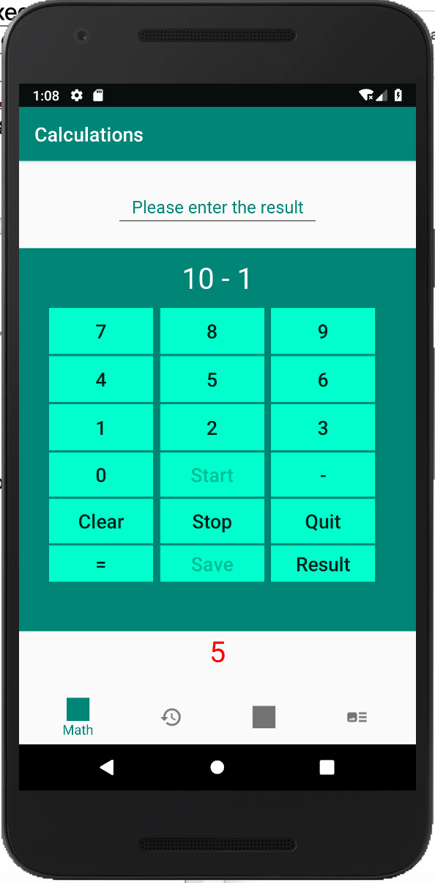

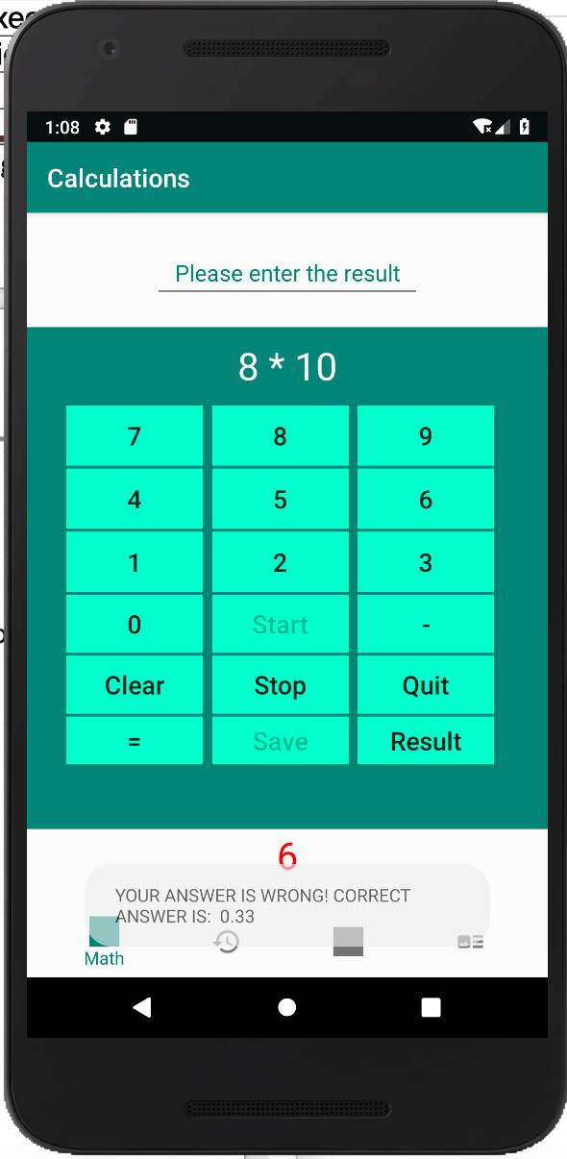

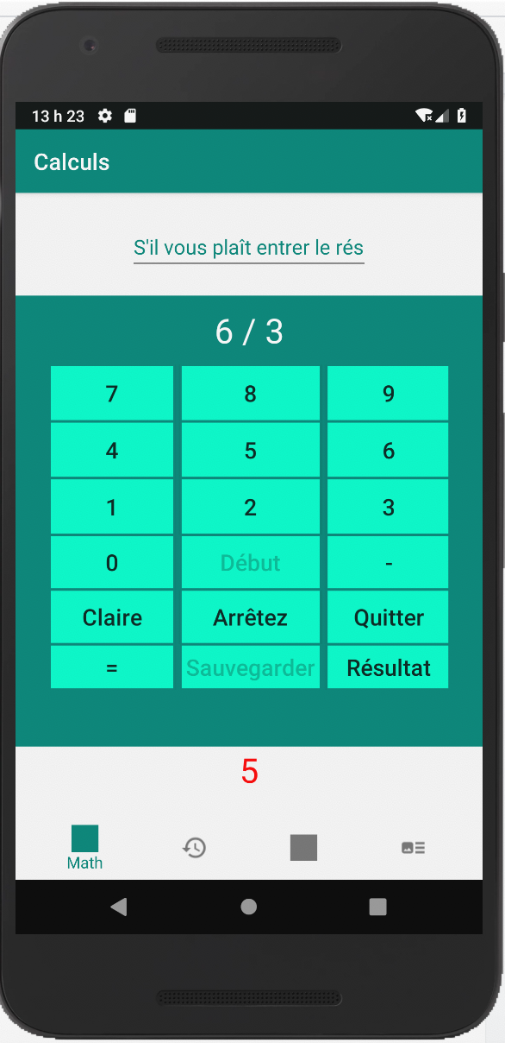

- The second UI with the results (all operations, % correct and wrong

answer)

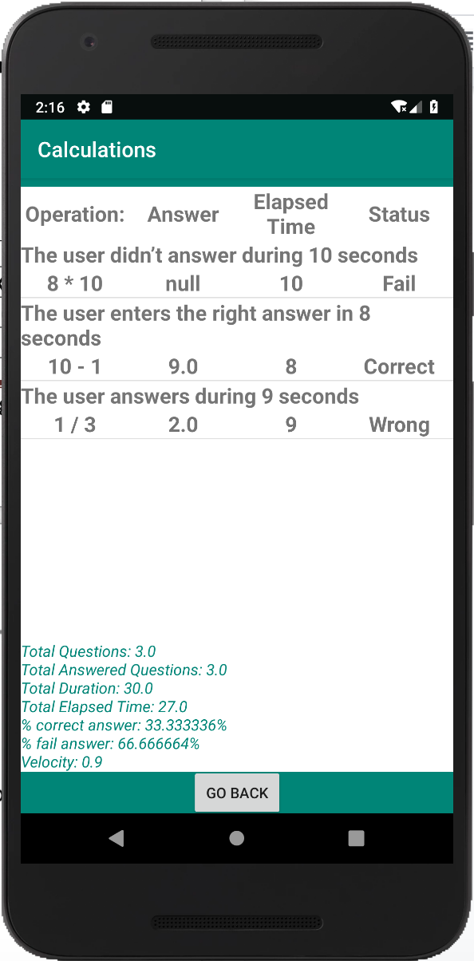

- The new features of the app

